Django Backend Architecture
1️⃣ Project root (backend root)
.
├── manage.py
├── db.sqlite3
├── requirements.txt
├── README.md
├── realestate_backend/
├── authapp/
├── users/
├── listings/
└── bookings/
🔹 manage.py
Command-line entry point for Django.
Used to:
- Run the server: python manage.py runserver
- Apply migrations
- Create superusers
- Run tests
Internally:
- Loads settings.py
- Bootstraps the Django app

🔹 db.sqlite3
Your development database.
- SQLite is default for local dev
- Stores:
  - Users
  - Listings
  - Bookings
  - Auth data
In production → usually PostgreSQL.

🔹 requirements.txt
Python dependencies list.
Example contents:
Django
djangorestframework
djangorestframework-simplejwt
Used for:
pip install -r requirements.txt

🔹 README.md
Documentation for:
- Setup instructions
- API usage
- Project overview
Important for team & deployment.

2️⃣ Core Django project: realestate_backend/
This is the configuration & wiring layer (not business logic).
realestate_backend/
├── settings.py
├── urls.py
├── asgi.py
├── wsgi.py
└── __init__.py

🔹 settings.py
Central configuration hub.
Controls:
- Installed apps (authapp, users, listings, bookings)
- Database connection
- Middleware
- Authentication
- REST Framework settings
- Security settings
Example responsibilities:
INSTALLED_APPS = [
'rest_framework',
'users',
'listings',
'bookings',
]

🔹 urls.py
Global URL router.
Connects app URLs together:
urlpatterns = [
path("api/auth/", include("authapp.urls")),
path("api/users/", include("users.urls")),
path("api/listings/", include("listings.urls")),
path("api/bookings/", include("bookings.urls")),
]
Acts like a traffic dispatcher.

🔹 wsgi.py
Used for production servers (Gunicorn, uWSGI).
- Handles synchronous HTTP requests
- Required for deployment

🔹 asgi.py
Used for async features:
- WebSockets
- Real-time notifications
- Chat
- Live booking updates
Useful later for:
- Booking status updates
- Agent chat

3️⃣ Apps = Domain-based backend modules
Each app represents a business domain.

🔐 authapp/ – Authentication & tokens
Purpose:
Handles login, registration, JWT tokens, authentication logic
authapp/
├── models.py
├── serializers.py
├── views.py
├── urls.py
├── apps.py
🔹 models.py
Defines auth-related models (if any).
Examples:
- OTP codes
- Refresh tokens
- Password reset tokens
Often light if using Django’s built-in User.

🔹 serializers.py
Handles:
- Login input validation
- Token serialization
- Password validation
Example:
class LoginSerializer(serializers.Serializer):
email = serializers.EmailField()
password = serializers.CharField()

🔹 views.py
Auth logic:
- Login
- Register
- Token refresh
- Logout
Example:
POST /api/auth/login/
POST /api/auth/register/

🔹 urls.py
Routes auth endpoints:
/api/auth/login/
/api/auth/register/
/api/auth/refresh/

🔹 apps.py
App configuration metadata.

👤 users/ – User profiles & roles
Purpose:
Manages user data beyond authentication
users/
├── models.py
├── serializers.py
├── views.py
├── urls.py
🔹 models.py
User-related domain data:
- Profile
- Role (buyer, agent, landlord, admin)
- Phone number
- Verification status
Example:
class Profile(models.Model):
user = models.OneToOneField(User)
role = models.CharField(...)

🔹 serializers.py
Converts user models ↔ JSON.
Handles:
- Profile updates
- Role exposure
- Read/write separation

🔹 views.py
User APIs:
- Get profile
- Update profile
- List agents
- View public user info

🔹 urls.py
Endpoints:
/api/users/me/
/api/users/<id>/
/api/users/agents/

🏠 listings/ – Properties & real estate inventory
Purpose:
Manages properties available for booking
listings/
├── models.py
├── serializers.py
├── views.py
├── urls.py

🔹 models.py
Defines property data:
Typical fields:
- Title
- Description
- Price
- Location
- Availability
- Owner/agent
Example:
class Listing(models.Model):
owner = models.ForeignKey(User)
price_per_night = models.DecimalField(...)

🔹 serializers.py
Controls:
- Public listing data
- Owner-only fields
- Validation
Example:
- Price must be positive
- Availability dates valid

🔹 views.py
Listing APIs:
- Create listing
- Search listings
- Filter by price/location
- View listing details

🔹 urls.py
Endpoints:
/api/listings/
/api/listings/<id>/
/api/listings/search/

📅 bookings/ – Reservations & availability
Purpose:
Handles booking logic & business rules
bookings/
├── models.py
├── serializers.py
├── views.py
├── urls.py

🔹 models.py
Defines booking data:
Fields:
- User
- Listing
- Check-in / check-out
- Status (pending, confirmed, canceled)
- Total price
Example:
class Booking(models.Model):
listing = models.ForeignKey(Listing)
user = models.ForeignKey(User)
status = models.CharField(...)

🔹 serializers.py
Validates:
- Date conflicts
- Availability
- Price calculation
This is where business rules live.

🔹 views.py
Booking workflows:
- Create booking
- Cancel booking
- View user bookings
- Owner booking management

🔹 urls.py
Endpoints:
/api/bookings/
/api/bookings/my/
/api/bookings/<id>/cancel/

4️⃣ __pycache__/ folders
These contain:
- Compiled Python bytecode (.pyc)
- Auto-generated
- Safe to ignore
- Never commit to git

5️⃣ How everything works together (real flow)
🔁 Booking a property
- User logs in
→ authapp
- User profile fetched
→ users
- User searches listings
→ listings
- User books a property
→ bookings
- Booking validated
→ checks conflicts, price, ownership
- Database updated
- Response returned as JSON

🔁 High-level request flow (API backend
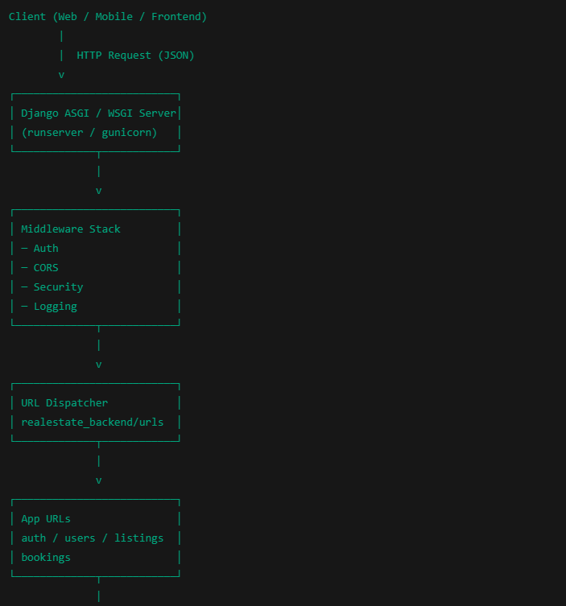
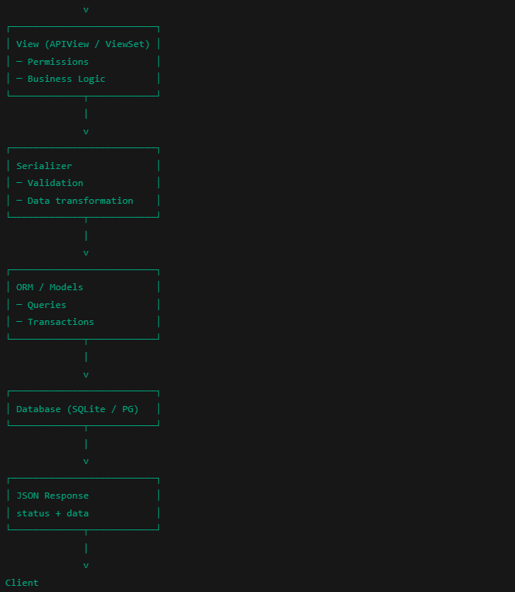

🏠 Example: Booking a property (concrete flow)
POST /api/bookings/
Authorization: Bearer <JWT>
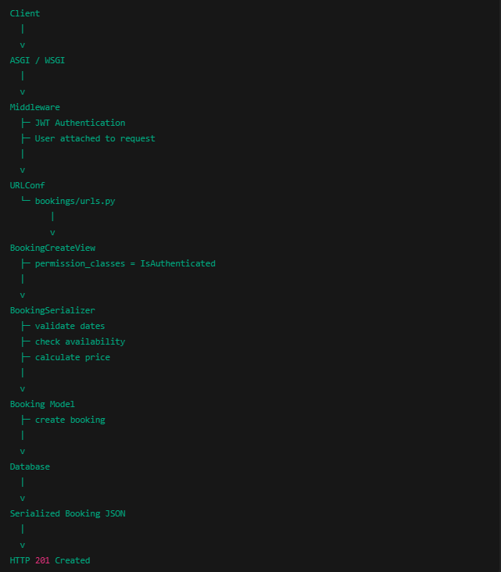

🔐 Auth request flow (JWT login)
POST /api/auth/login/

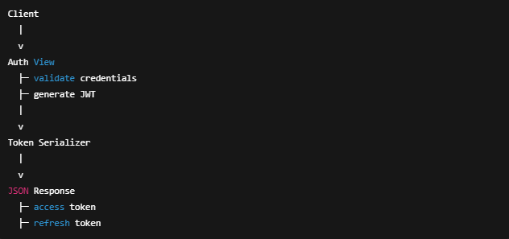

React Frontend Architecture
1️⃣ High-level architecture (mental model)
Your frontend follows a clean layered architecture:
Pages (Screens)
↓
Components (UI building blocks)
↓
Hooks & Contexts (State & logic)
↓
Services (API calls)
↓
Django REST Backend
This separation is exactly what you want for scalability.

2️⃣ Root level (build & tooling)
.
├── index.html
├── vite.config.js
├── package.json
├── eslint.config.js
├── public/
└── src/
🔹 index.html
The single HTML entry point (SPA).
Contains:
<div id="root"></div>
React mounts here.

🔹 vite.config.js
Vite build configuration:
- Fast dev server
- Hot module reload
- Optimized production builds

🔹 package.json
Defines:
- Dependencies (React, Router, Axios, etc.)
- Scripts:
- "dev", "build", "preview", "test"

🔹 eslint.config.js
Code quality rules:
- Prevents bugs
- Enforces style consistency

🔹 public/
Static assets served as-is:
- Favicons
- SVGs
- Images

3️⃣ src/ — the real application
src/
├── main.jsx
├── App.jsx
├── routes/
├── pages/
├── components/
├── contexts/
├── hooks/
├── services/
├── utils/
├── assets/
└── tests/

🔁 App bootstrap flow
🔹 main.jsx
Application entry point.
Responsibilities:
- Create React root
- Wrap app in providers (Auth, Router)
Typical flow:
<AuthProvider>
<BrowserRouter>
<App />
</BrowserRouter>
</AuthProvider>

🔹 App.jsx
Top-level app shell.
Usually contains:
- Global layout
- Route mounting
Think of it as:
“The container for everything”

4️⃣ Routing layer
src/routes/AppRoutes.jsx
🔹 AppRoutes.jsx
Defines URL → Page mapping.
Example:
<Route path="/login" element={<Login />} />
<Route path="/property/:id" element={<PropertyDetails />} />
Handles:
- Public routes
- Protected routes (auth required)
- Dashboard routes

5️⃣ Pages (screens)
src/pages/
Each file = one screen / route.
Examples:
- Home.jsx
- PropertyDetails.jsx
- Dashboard.jsx
- AddProperty.jsx
🔹 _PageShell.jsx
Shared page wrapper:
- SEO
- Layout consistency
- Meta tags

🔹 Page responsibilities
Pages:
- Fetch data
- Coordinate components
- Handle navigation
They do NOT:
- Call APIs directly
- Store global state
That’s done via services & hooks 👇

6️⃣ Components (reusable UI)
src/components/
├── common/
└── layout/
🔹 layout/
Global UI:
- Header.jsx
- Footer.jsx
- MainLayout.jsx
Used across pages.

🔹 common/
Reusable, generic components:
- SEO.jsx
- Buttons
- Modals (future)

7️⃣ State management (Auth & shared state)
src/contexts/
├── AuthContext.jsx
🔹 AuthContext.jsx
Central authentication state:
- Current user
- JWT tokens
- Login/logout logic
Provides:
{ user, login, logout, isAuthenticated }

🔹 Why this matters
Avoids:
- Prop drilling
- Duplicate auth logic
- Token mismatch bugs

8️⃣ Custom hooks (logic reuse)
src/hooks/
├── useAuth.js
├── useFetch.js
🔹 useAuth.js
Thin wrapper around AuthContext.
Usage:
const { user, logout } = useAuth();

🔹 useFetch.js
Reusable data fetching logic:
- Loading state
- Error handling
- API calls
Prevents copy-pasting fetch logic.

9️⃣ Services (API communication layer)
src/services/
This is the bridge to Django.
🔹 apiClient.js
Central HTTP client (Axios/fetch):
- Base URL
- Authorization headers
- Interceptors
Example:
Authorization: Bearer <JWT>

🔹 endpoints.js
Single source of truth for API URLs:
export const BOOKINGS = "/api/bookings/";
Avoids hard-coding strings everywhere.

🔹 Domain services
Each matches a Django app:
Service | Django App
auth.service.js | authapp
users.service.js | users
listings.service.js | listings
bookings.service.js | bookings
Example:
createBooking(data)
→ POST /api/bookings/

🔁 Frontend → Backend request flow (real example)
User books a property
PropertyDetails.jsx
|
v
bookings.service.js
|
v
apiClient.js
|
v
POST /api/bookings/
|
v
Django bookings app

🔟 Utilities & helpers
src/utils/
🔹 constants.js
Global constants:
- Roles
- Status codes
- Config values

🔹 format.js
Formatting helpers:
- Dates
- Prices
- Text

🔹 storage.js
Local/session storage abstraction:
- JWT persistence
- User caching

1️⃣1️⃣ Assets & styling
src/assets/
Includes:
- CSS
- Images
- Icons
Supports:
- Global styles
- Component-level styles

1️⃣2️⃣ Testing
src/tests/
🔹 smoke.test.jsx
Basic sanity test:
- App renders
- No crash on load
Foundation for:
- Component tests
- Integration tests

🧭 A. High-level Frontend Request Flow
(START)
|
v
[User Interaction]
(click / submit / navigation)
|
v
[Page Component]
(Home, PropertyDetails, Dashboard)
|
v
[UI Components]
(Header, Forms, Cards)
|
v
[Custom Hook]
(useAuth / useFetch)
|
v
[Service Layer]
(auth.service / listings.service / bookings.service)
|
v
[API Client]
(apiClient.js)
|
v
[HTTP Request]
(REST / JSON)
|
v
[Django Backend API]
|
v
[HTTP Response]
(JSON)
|
v
[Service Layer]
(parse response)
|
v
[Hook Updates State]
(loading / data / error)
|
v
[Context Updates Global State]
(AuthContext)
|
v
[React Re-render]
|
v
(UI Updated)
|
v
(END)

🔐 B. Authentication Flow (Login)
(START)
|
v
[User submits Login Form]
|
v
<Login Page>
|
v
useAuth()
|
v
auth.service.login()
|
v
apiClient.post("/api/auth/login/")
|
v
{Login Successful?}
| |
No Yes
| |
v v
[Show Error] [Receive JWT Tokens]
|
v
storage.js (save tokens)
|
v
AuthContext.setUser()
|
v
Protected Routes Unlocked
|
v
(END)

🏠 C. Listings Retrieval Flow
(START)
|
v
[User visits Listings Page]
|
v
<PropertyGrid Page>
|
v
useFetch()
|
v
listings.service.getListings()
|
v
apiClient.get("/api/listings/")
|
v
[JSON Response]
|
v
useFetch updates state
|
v
<Property Cards Rendered>
|
v
(END)

📅 D. Booking Creation Flow
(START)
|
v
[User clicks "Book Now"]
|
v
<PropertyDetails Page>
|
v
useAuth() → check login
|
v
{Authenticated?}
| |
No Yes
| |
v v
[Redirect] bookings.service.createBooking()
|
v
apiClient.post("/api/bookings/")
|
v
{Booking Accepted?}
| |
No Yes
| |
v v
[Show Error] [Booking Confirmed]
|
v
Update UI / Redirect
|
v
(END)

Connecting Frontend to Backend
1️⃣ Set up the backend to serve the frontend
Since your React frontend is SPA (Vite) and Django backend is REST API:
- Keep them decoupled (recommended)
  - Django only exposes API endpoints (/api/...)
  - React handles all UI and routing.
- Enable CORS in Django so frontend can access the backend from a different origin.
# settings.py
INSTALLED_APPS += ['corsheaders']

MIDDLEWARE = ['corsheaders.middleware.CorsMiddleware'] + MIDDLEWARE

CORS_ALLOWED_ORIGINS = [
"http://localhost:5173", # your Vite dev server
"https://yourfrontenddomain.com"
]

2️⃣ Connect React frontend → Django backend
🔹 API Client (already exists)
You already have:
src/services/apiClient.js
- Configure baseURL to point to your Django backend.
Example using Axios:
import axios from "axios";

const apiClient = axios.create({
baseURL: import.meta.env.VITE_API_BASE_URL || "http://localhost:8000",
headers: {
"Content-Type": "application/json",
},
});

// Add JWT token automatically
apiClient.interceptors.request.use((config) => {
const token = localStorage.getItem("access_token");
if (token) config.headers.Authorization = `Bearer ${token}`;
return config;
});

export default apiClient;

3️⃣ Match frontend services to backend apps
Your backend apps:
Django App | React Service
authapp | auth.service.js
users | users.service.js
listings | listings.service.js
bookings | bookings.service.js
- Each React service calls the corresponding backend endpoints.
- Example: listings.service.js
import apiClient from "./apiClient";

export const getListings = async () => {
const response = await apiClient.get("/api/listings/");
return response.data;
};

4️⃣ Handle authentication
- Backend: authapp provides JWT tokens.
- Frontend: AuthContext.jsx + useAuth.js stores and provides token.
- API client sends token in Authorization header.
Flow:
LoginPage -> useAuth() -> auth.service.login() -> apiClient.post("/api/auth/login/")
-> Response { access, refresh }
-> store in localStorage -> AuthContext.setUser()

5️⃣ Consume backend endpoints in pages
Example: Booking a property
PropertyDetails.jsx
|
v
useAuth() -> check login
|
v
bookings.service.createBooking(propertyId)
|
v
apiClient.post("/api/bookings/", { property_id })
|
v
Backend booking view validates -> creates booking -> returns JSON
|
v
Service updates frontend state / shows success or error

6️⃣ Align routes & URLs
- Frontend URLs: /login, /listings, /property/:id
- Backend URLs: /api/auth/login/, /api/listings/, /api/bookings/
- Always prefix backend routes with /api/ to avoid collisions with React routes.

7️⃣ Optional: Deployment setup
- Development: React runs on Vite dev server, Django on localhost:8000. Use CORS.
- Production: Options:
  - Serve frontend via Django’s static files (collectstatic)
  - Serve frontend separately (Vercel, Netlify) and point API requests to Django backend.

8️⃣ Checklist for connecting frontend ↔ backend
- Backend exposes REST endpoints for all apps.
- Backend allows CORS from frontend.
- Frontend apiClient configured with backend baseURL.
- Frontend services match backend apps.
- Auth flow: JWT token stored, sent in headers.
- Pages call services → services call backend → response updates state/context.
- URLs are aligned: frontend SPA URLs vs backend /api/....

